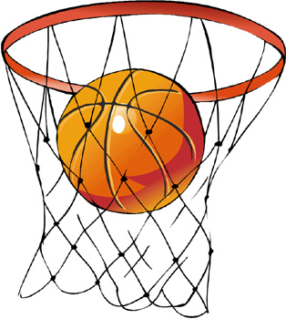

Basketball

-University of the Incarnate Word-

Intramural Sports

Basketball Rules
Each player must present a valid UIW ID Card before each contest to be eligible to participate.
No Exceptions.

- All high school rules will govern play with exception of the following:
- Teams may not pick up people from other teams & must only play with players from their registered roster!
- If a team does not have the required players by 5 minutes after game time, then they will forfeit the game.
- Maximum number allowed on any roster is 12.
- Players are only allowed to be on 1 team roster!
- The game will consist of two 15-minute halves and a 3-minute half time, and a 5-minute overtime if necessary.
- 5 personal fouls per player
- No shot clock
- 10 second backcourt violation
- Offensive 3 second violation
- 5 second inbound violation
- The clock will run non-stop until the final two minutes of each half.
- During the last two minutes, the clock will stop on all dead balls.
- An official or team time-out will stop the clock during the first 13 minutes.
- Time-outs will last one minute and half time will last three minutes.
- Teams have three (3) time-outs per game.
- Each team MUST have matching, numbered jerseys for every player. These will be provided.
- Your team captain will specify your team's color at the time of registration.
- No basket may be scored on a player control (charging) foul, regardless of when the ball is released.
- Two technical fouls on a player or coach will result in an automatic ejection from the game. The ejection player must also leave the playing area.
- Teams will enter the bonus on the 7th team foul. On a teams 10th foul, all fouls will result in two free throws.
- There will be a 30-point mercy rule after 8 minutes in the second half. In the judgment of the officials and supervisor, if a team is dragging or allows the team behind to make up baskets so the game will not be stopped, the game will be stopped immediately.
- Substitutes must report to the score's table and beckoned in by the officials. Illegal substitutions will result in a technical foul.
- Slapping the backboard is not a technical in itself, but intentionally hitting the backboard hard enough to alter the flight of the ball will result in a technical. Unsportsmanlike conduct will not be tolerated.
- The following behaviors will result in a technical foul and the possibility of a game suspension.
  - Cursing at the officials, supervisors, or opposing players
  - Insulting the officials, supervisors, or opposing players
  - Participating in a fight (AUTOMATIC EJECTION)
- Other unsportsmanlike acts will also earn a technical foul.
- All unsportsmanlike fouls result in two free throws and the ball, regardless of whether the foul is on a player or the bench.

